Documentation for Data Visualization:  
  
Captured KPI metrics and Created visualizations for the following for the following metrics:

**Quantity Sold by Dealer ID:**

**Profit by Date and Model:**

**Profit by Year and Dealer ID:**

**Sum of Profits for Hudson model cars by Dealer ID:**

**Create the charts for above KPI metrics.  
Quantity Sold by Dealer ID:**

**Create the pivot table in the Excel sheet. On the Sheet1. Convert the Excel to pivot table and select new workbook. Drag and Drop DealerID into rows and profits into Values.**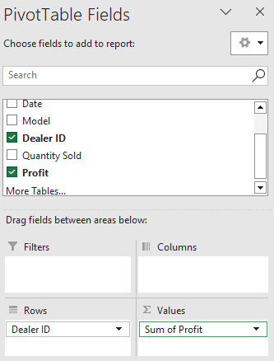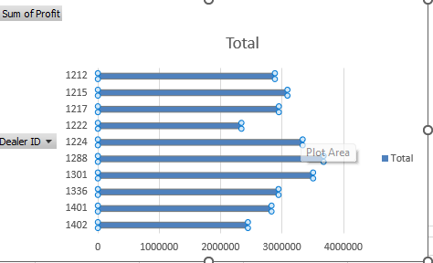

**As a Active member of IBM Cognos tool I logged in into my account, upload your Excel file.  
After uploading GO to contents folder.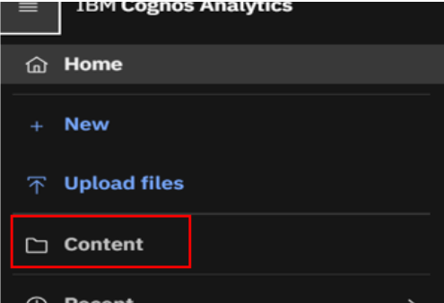 After selecting the Excel file in the content folder -🡪Select Create dashboard. You can select one of the sample dashboards in the tool. We have 5 KPI metrics need to captured on the dashboard. (DealerID, profit by year, Quantity sold, Profit by Dealer year and model, profit by model).**

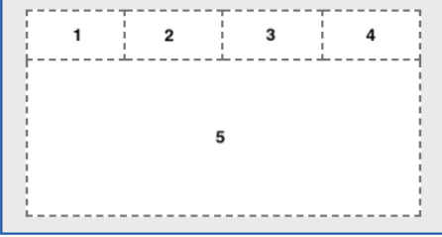

**On the Panel 1. Drag and Drop the values from left-side panel into right-side panel and the sum of profits. And do the rest for the other panels to. Clickon the bar types if necessary.**